Laryngitis



**You open your mouth to talk, and all that comes out is a whisper or squeak. You’ve got laryngitis. And you may wonder: How did this happen?**

**Swelling in the voice box, also known as the larynx, causes laryngitis. This organ is in your upper neck just beyond the back of your throat. An infection, such as a cold, the flu, or bronchitis, may spur the swelling. Or the problem could be something as simple as overuse.**

**The vocal cords, two folds of tissue within your larynx, become inflamed. Sound from the area is muffled, and you are hoarse.**

**Laryngitis usually isn’t a big deal. With proper treatment, it should go away in no more than 3 weeks. But you have ways to stop it from happening or make it go away faster.**

**Laryngitis is often related to another illness, such as cold, flu, or bronchitis. Symptoms include:**

* **Sore throat**
* **A low-grade fever**
* **Hoarseness**
* **Trouble speaking**
* **A dry cough**
* **A constant urge to clear your throat**
* **Swollen glands**

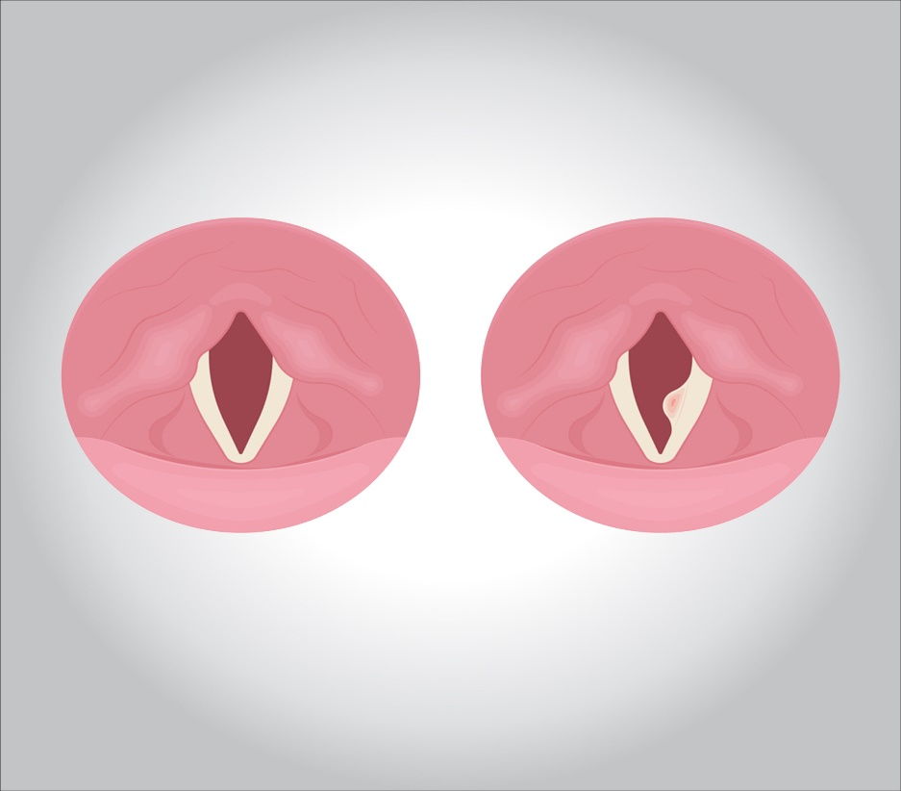

**You have a greater chance of getting it if you smoke, overuse your voice a lot (if you are a singer or public speaker, for example), or are prone to colds, the flu, and bronchitis.**

**What are possible causes?**

**Though it’s usually virus-related, there are also ongoing, or chronic, forms of the illness, generally brought on by smoking and alcohol abuse.**

**Acid reflux can also play a role. Strong acids can travel up from the stomach into your throat and get all the way to your larynx. This can irritate it and make you lose your voice.**

**Other causes of chronic cases include:**

* **Allergies**
* **Bacterial infection**
* **Fungal infection, such as thrush**
* **Injury, such as a hit to the throat**
* **Inhalation of chemical fumes**
* **Sinus disease**
* **Some health conditions, including cancer, can also help cause laryngitis.**

**Treatments and Medications**

**The best treatment is to rest your voice. Without the stress of everyday use, it will often recover on its own. If your need to speak clearly is urgent, a doctor may prescribe corticosteroids. This is a class of man-made drugs that mimic hormones, such as cortisol, that your body makes naturally. They reduce swelling.**

**You can try a number of home remedies to aid in your healing:**

* **Drink plenty of fluids. Early on, swallowing may be painful, but the more you’re hydrated, the better. But, avoid alcohol and caffeine.**
* **Use humidifiers and menthol inhalers. Moisture is your friend, and menthol can be soothing.**
* **Gargle with warm salt water. The salinity not only soothes the area, but also reduces swelling.**
* **Avoid dry, smoky, or dusty rooms.**
* **You may also suck on throat lozenges, which often contain herbs such as eucalyptus and mint, known for calming sore throats.**

**What Not to Do**

**Stay away from decongestants. They dry you out when your throat wants moisture.**

**Certain herbs — such as licorice, marshmallow, and slippery elm — have reputations as throat pain relievers, but they interact with some medications. Talk to your doctor before taking them.**

**When Should I See a Doctor?**

**Laryngitis in adults is not serious, but you should see a doctor if you’ve been hoarse for more than 2 weeks, are coughing up blood, have a temperature above 103 F, or are having trouble breathing.**

**However, it can be very serious in children. Watch for fever and call a doctor if:**

* **Your child is younger than 3 months old and has a temperature of 100 F or higher or is older than 3 months old has a fever of 102 F or higher.**
* **He’s having trouble swallowing or breathing, or is making high-pitched sounds when inhaling, or drooling more than usual.**

**In kids, it may lead to croup, a narrowing of the airways, or epiglottitis, an inflammation of the flap at the top of the larynx. This condition can be life-threatening, so get emergency treatment if you or a child in your care has had laryngitis and starts gasping or having any trouble breathing.**